**Name: Khushi Habbu**

**Reg no -20BCE1612**

**Task 5 -screenshots**

Vm -ubuntu in my name 

**Task execution as per the read me documentation of 9 steps**

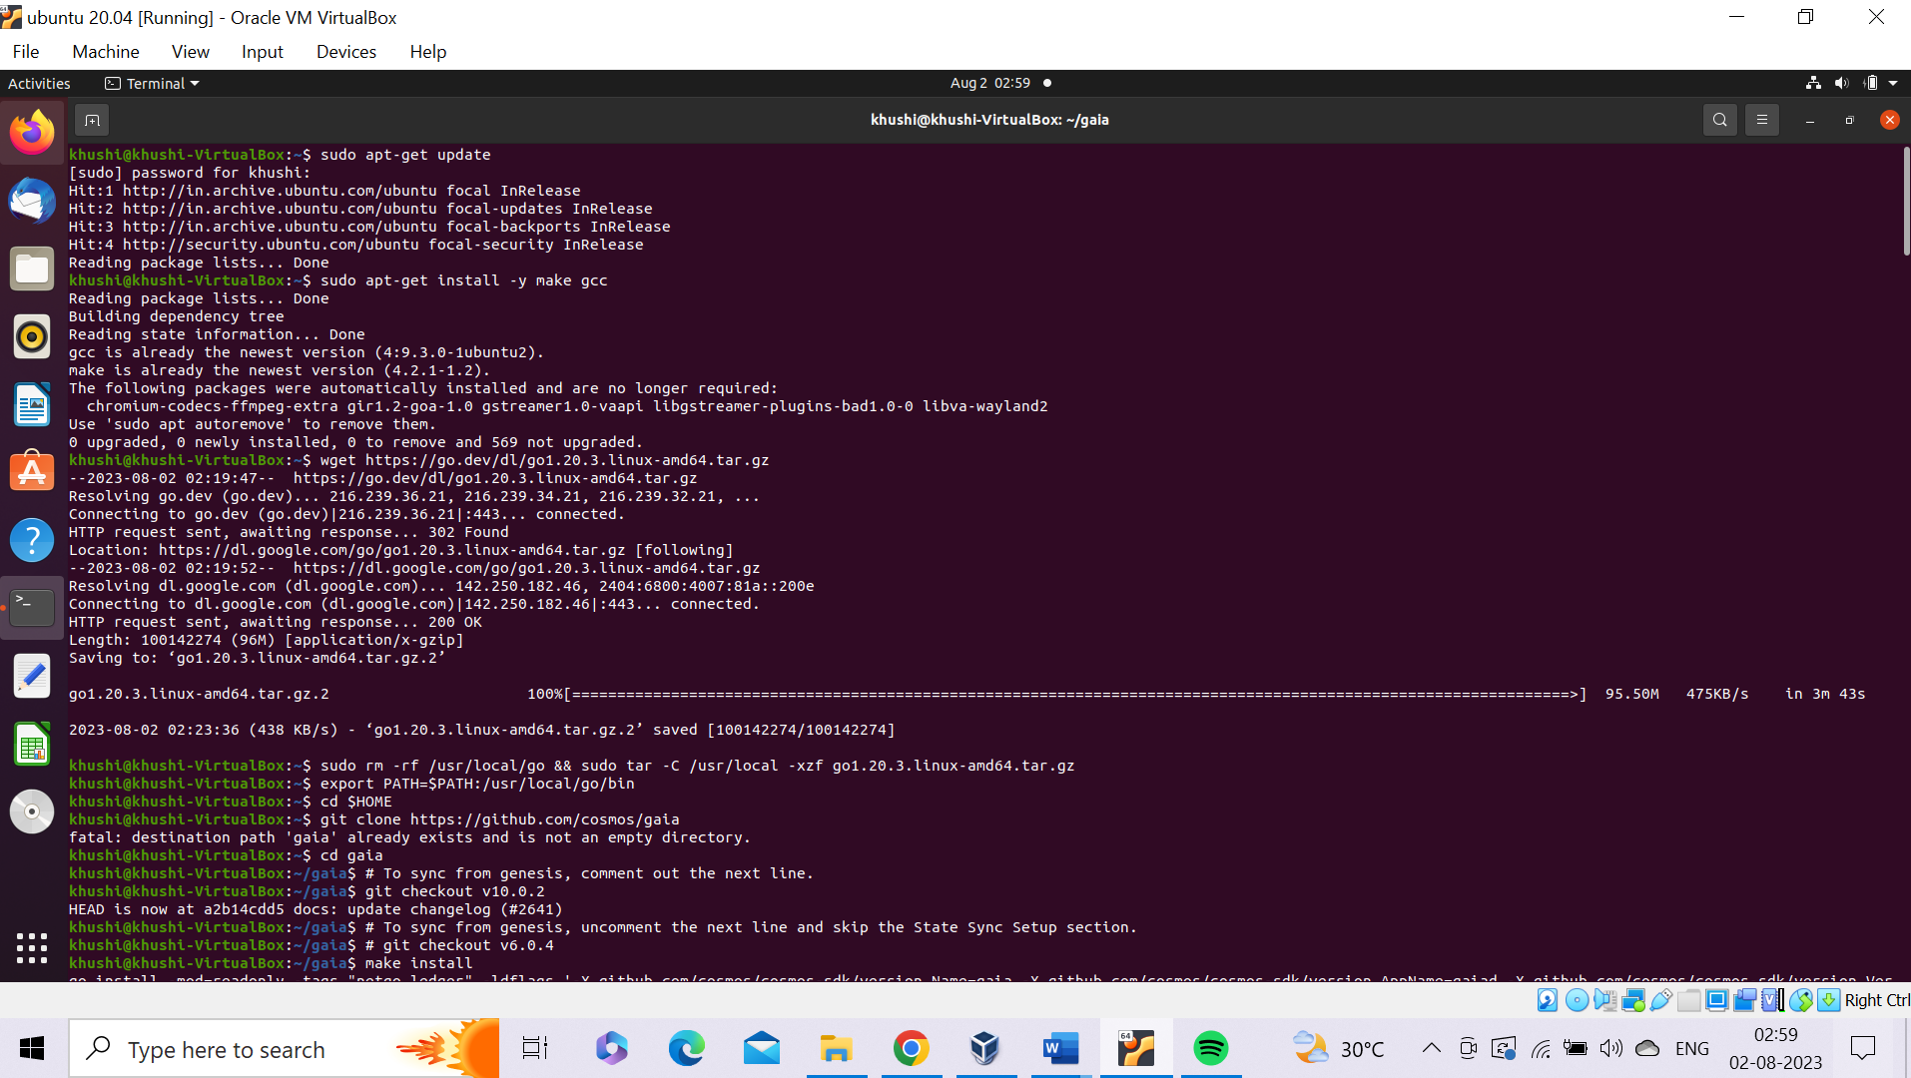

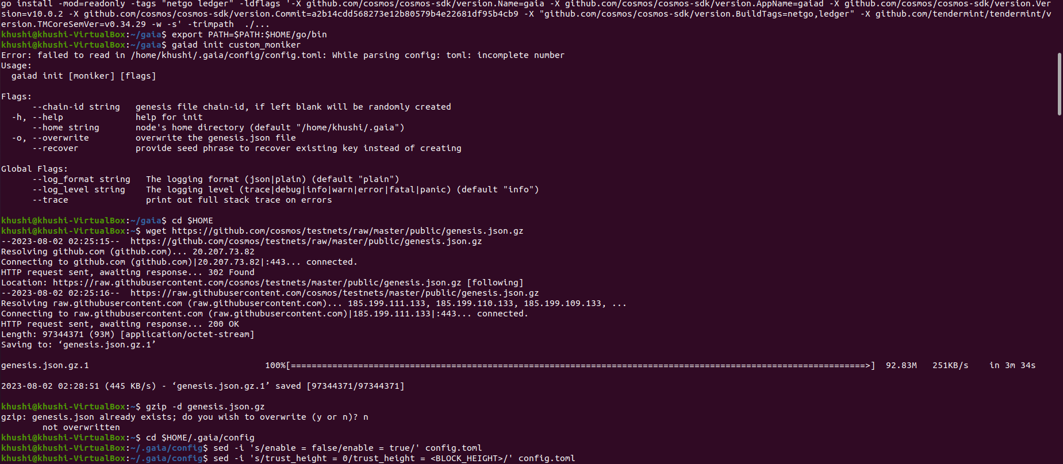



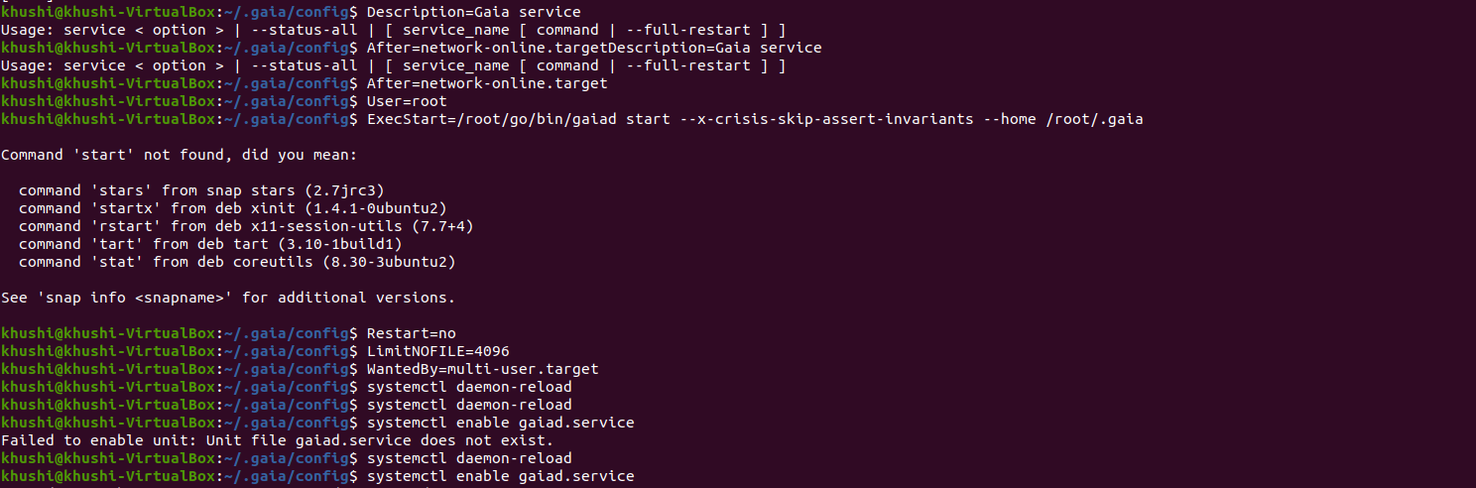

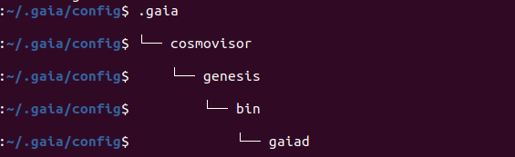

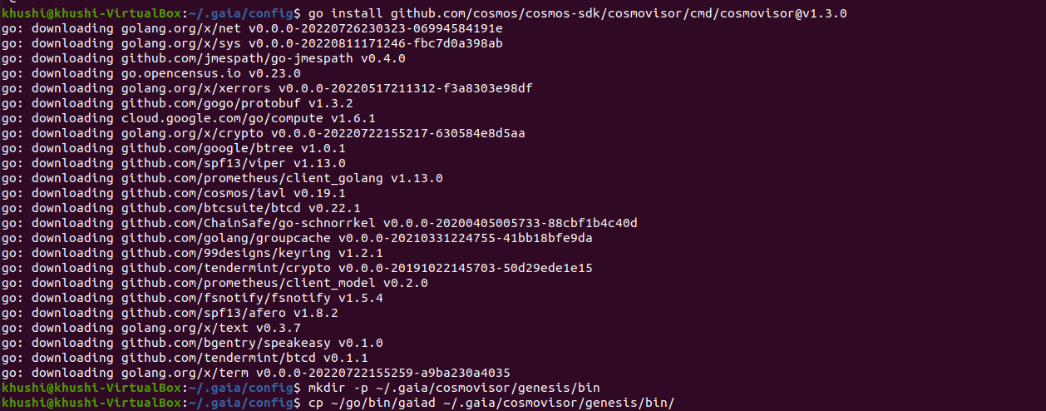

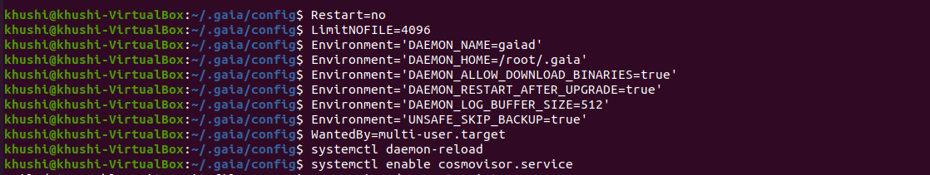

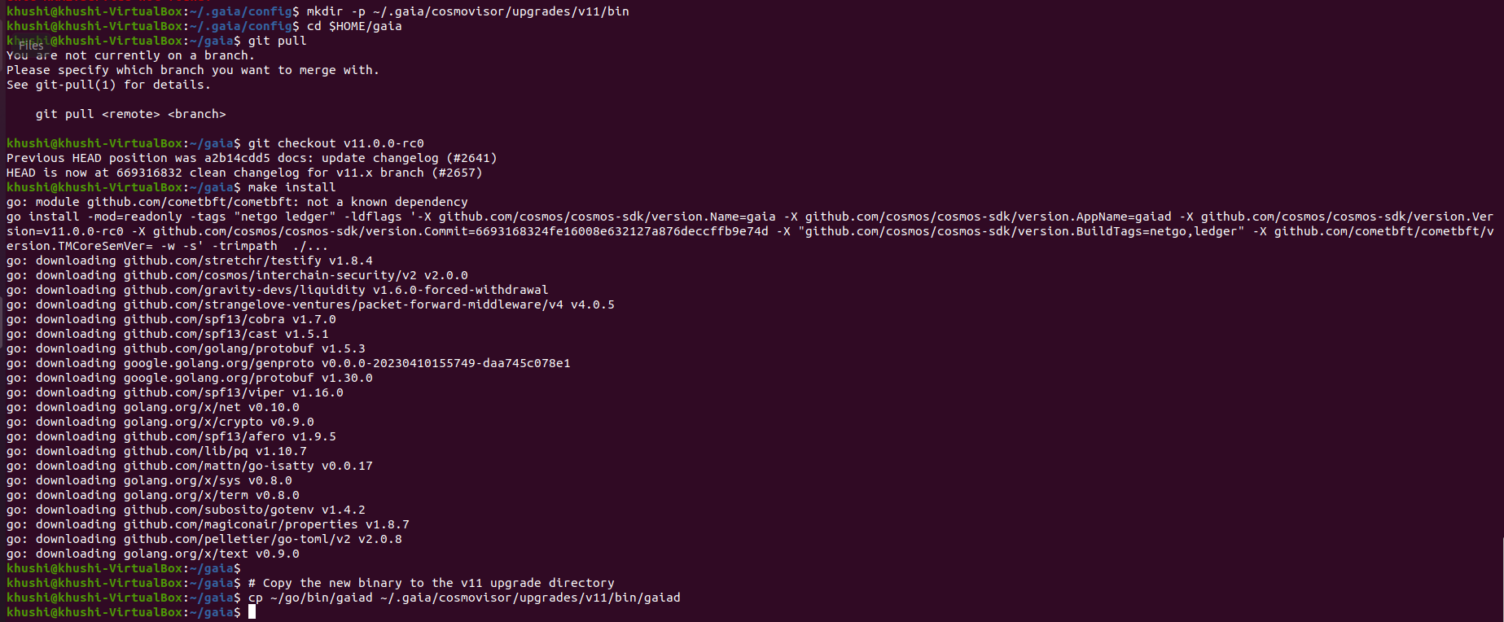

**Finally, after 9 steps node is working and is also ready to upgrade node and copy the binary to the v11 upgrade directory**